*Project:*

**Project Working Title:** Differential Scattering of Neutrinos about a Schwarzschild Black Hole

**Project End Date**: 7 May 2022 (The end of week 6 of spring term)

*Student:*

**Name**: Thomas Knudson

**Affiliation:** Department of Physics, Oregon State University

*Statement*: I will work regularly and diligently on this project throughout the year and initiate meetings with my advisor to seek feedback and guidance on the research. I understand that a significant portion of the research should be completed by the end of winter term to enable me focus on the writing process in the PH403 class.

Student Signature: _____________________________

*Advisor:*

**Name** Dr. Kathryn Hadley

**Affiliation**  Department of Physics, Oregon State University

I have read this thesis proposal. I agree that the scope is reasonable for completion by May 7, 2021 and that sufficient progress can be made by early winter term 2021 to allow significant revision of the thesis during the winter and spring terms of 2021.

Advisor Signature*:* _____________________________

**Project Summary**

Using various models of spacetime, we will endeavor to determine the minimum stable orbit for a collection of neutrinos above the event horizon of a series of increasingly complicated black holes. By solving the geodesic equations for each spacetime, we can discuss the trajectories of the neutrinos and whether or not they correspond to a stable and circular orbit. There already exists the notion that light can establish a stable circular orbit just above the event horizon, where each wave/photon will remain until the black hole expands/contracts and alters the trajectory of the trapped light. In an equilibrium situation, this light will be trapped for eternity and form a complete spherical shell that an observer could only grasp a flash of as they descend into the black hole. This will be analyzed by plotting the impact parameter versus the angle of incidence to discover valid geodesics for neutrinos.

**Project Description**

*Introduction*

Neutrinos, given their small mass and weak interaction with matter, form an excellent test particle for use in examining orbital behaviour. The deeper understanding we have of interactions of particles near the event horizon of a black hole, the better we can improve and/or optimize our models and numeric solutions to multi-body systems in the framework of General Relativity. The treatment of neutrinos in a Schwarzschild geometry sets an excellent stage for comparing the results of the more complicated models against and will begin by exploring valid parameters of energy and orbital angular momentum for a circular geodesic described by Equation 1 below[1].

Please **include a figure** or two (see Figure 1). Mention each and every figure somewhere in the main text, explaining how the figure relates to your proposal. A simple hand-drawn schematic can be indispensable for helping the reader understand your work. Labels on the figure should be sized to match the main text font size. In addition to mentioning the figure in the main text, the figure must also have a descriptive caption that helps the reader interpret the figure. The caption is underneath the figure. The caption is single spaced and indented to distinguish it from the main text.

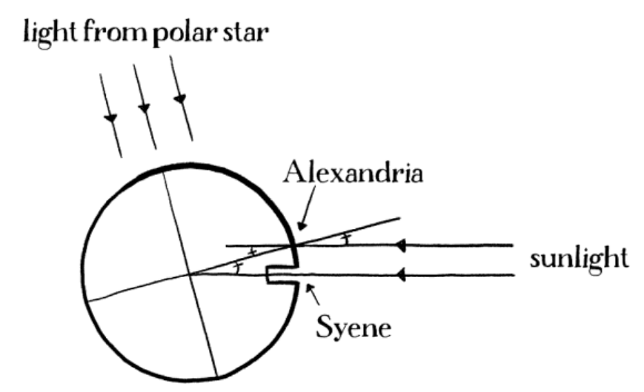

**Figure 1**. Eratosthenes devised the first method to determine the size of the Earth. When Sunlight reaches the bottom of a well in Syene, the same light makes a 7-degree angle relative to a vertical pole in Alexandria. Figure credit: “Drawing Physics” by D.S. Lemons.

If you include equations, remember that equations contain nouns and verbs and they should be part of the syntactic flow of the sentence whether they are in-line like this, *V* = *IR*, or stand-alone, numbered equations like this one,

$\left\langle θ | \hat{H} | φ\right\rangle =\int_{-∞}^{∞}{θ^{*}\left(x\right)\hat{H}φ\left(x\right)dx}$. (1)

This introductory section is one of the two most important in the proposal, along with the plan of work, so devote appropriate space. After reading the introduction, the reader should understand which basic physics principles underpin your work.

*Plan of work*

The project description contains a clear statement of work and should include objectives. Outline the general plan including the broad activities to be undertaken, a clear description of experimental, computational and/or theoretical methods and procedures. What do you plan to do, how will you do it and how will you know when you have succeeded? **Include figures** as appropriate. It will be very unusual if there are no figures. Preliminary data/results are not required, but if you have them, include them because it will explain where you are in the process. Are collaborators involved in your work? If so, describe their roles.

This section is one of the two most important in the proposal, along with the introduction or context, so devote appropriate space, and go well beyond restating the summary. After reading the plan of work, the reader should understand how you plan to accomplish the task.

*Timeline*

Include a timeline for the research work (experimentation, computation, data analysis, *etc*. as appropriate), literature review and writing. Writing should be in parallel with the research, not after it. This paragraph shows that you have given thought to planning the work, and that you are aware of the importance of time management. If you have completed a portion of the work, that's fine, simply make clear what has been done and what is left to do.

*Data management*

Plan for data management (1-2 paragraphs). This paragraph shows that you understand that your data and samples must be appropriately recorded and stored for later review. If you are a computationalist, you may generate large amounts of data, so digital storage may need special consideration. If you are in Physics Education, there may be special issues related to use of human subjects.

*Facilities, Equipment and Other Resources*

What equipment, samples, computers, etc. do you need and who will provide them? Here you will demonstrate that you understand the scope of your work, the extent to which you may have to rely on collaborators, and scheduling of time on specialized equipment, among other things.

**References Cited**

[1] D. O. Muhleman, D. B. Holdridge, and N. Block, "The astronomical unit determined by radar reflections from Venus”, Astronomical Journal **67**, 191–203 (1962).

This list of references cited includes at least 4 or 5 papers or text books that are relevant to your project. References must be in the example format and must include the title of the article.

**Format**

Text must be in single column format with 1-inch margins. Use 1.5 or double spacing between lines of text (this helps the peer review process). Use 10-point to 12-point Arial, Times, Times New Roman or Cambria fonts. Do not exceed 8 pages excluding the coversheet and curriculum vitae (see below). Number each page. Remove anything in red in this template.

Curriculum Vitae  
Your name, Department of Physics Oregon State University

Education: B.S. Physics, Oregon State University (expected 2021)

Employment: (could be paid or volunteer)

Honors: (fellowships, scholarships, awards, recognition)

Professional affiliations: (SPS, APS, AAPT, other science/engineering or student societies …)

Relevant experience or skills: (research, courses, programming, database, management ...)

Outreach activities:

Publications or presentations:

Do not include names of references, personal information such as gender, citizenship, marital status *etc*.

**Format:** 2-page maximum, but otherwise organize and format as you prefer.